ClaimLens

1. The pitch
Upload photos of your damaged car and the body shop's repair estimate; ClaimLens checks, line by line, whether the estimate matches the damage you can actually see.
A repair estimate is a long list of part codes and labor hours that most car owners can't read. ClaimLens runs end to end on the Meta Model API. SAM 3.1 finds each car part and damaged area in the photos. Muse Spark reads the photos and the estimate PDF, then works as an agent, calling validation tools to reconcile the two. The result is a plain-language report: lines with no visible damage behind them, visible damage the estimate missed, "replace" where "repair" looks enough, and labor that looks out of range, each with photo evidence.

2. The problem, and why it's mine
After a car accident, the owner gets a repair estimate they can't evaluate: dozens of lines like "R&I frt bumper cover" and "refinish 2.4 hrs." They can't tell whether it covers all the damage, includes work that isn't needed, or replaces parts that could be repaired. Checking it today means paying for a second estimate or trusting the shop.
ClaimLens is reconciliation, done for the person who actually owns the car.
What's newly possible: until recently, matching a photo of a dented door to the line "repair LF door outer panel" needed a trained appraiser. SAM 3.1 can now isolate parts and damaged areas from a text prompt, and Muse Spark can read both the photos and the estimate, so the matching becomes a data problem I know how to solve.

3. What needs to be built
A mobile-friendly web app: photos and an estimate go in, an evidence-backed check comes out.
- Upload. The owner adds 4–10 photos of the damage and the repair estimate as a PDF or a photo of the printout.
- Find parts and damage. SAM 3.1, called through the Meta Model API, segments car parts by text prompt ("front bumper", "headlight", "left front door") and damaged areas ("dent", "scratch", "crack"). The overlap says which parts are damaged. To keep calls down, Muse Spark first lists the parts visible in each photo, and SAM 3.1 is asked only about those.
- Assess each part. Muse Spark's image understanding looks at each damaged-part crop. Structured output returns JSON in schema: part, damage type, severity, repair-or-replace likelihood and confidence.
- Read the estimate. The estimate PDF goes straight to Muse Spark through the API's file handling, with no separate OCR step. Structured output returns every line: part, operation, labor hours, price.
- Reconcile with an agent. A Muse Spark agent loop (Responses API with tool calling) works through the car part by part, calling tools, in parallel where it can:
  - normalize_part_name: maps "frt bpr cvr" to front bumper cover
  - match_damage: pairs estimate lines with observed damage and scores the match
  - check_labor_range: compares hours with a reference table in DuckDB
  - record_flag: saves a flag only if it fits the schema and cites a photo crop or estimate line
- Report. Flags cover lines with no visible damage, damage with no line, repair-vs-replace mismatches, duplicates and unusual labor. Each shows its evidence, reason and confidence, plus questions to ask the shop.
ClaimLens doesn't price repairs or give insurance advice. It shows owners what to ask about, with evidence.

4. How it uses the Meta Model API
Every model call goes through the Meta Model API with one key and its OpenAI-compatible SDK. Muse Spark is the agent; SAM 3.1 and validation code are its tools; every output is schema-checked JSON.
Meta model or API feature | How ClaimLens uses it
SAM 3.1 (Meta Model API) | Takes a short noun phrase ("front bumper", "dent") and returns a box and mask for every match; $2.50 per 1,000 images
Muse Spark 1.3: image understanding | Lists which parts are visible in each photo, then judges damage type and severity on each SAM crop
Muse Spark 1.3: file handling | Reads the estimate PDF directly, no separate OCR step
Structured output (JSON schema) | Damage assessments, estimate lines and flags all match schemas generated from my Pydantic models, which double as the data contract
Tool calling, in parallel | The reconcile agent calls normalize_part_name, match_damage, check_labor_range and record_flag
Responses API, reasoning effort, prompt caching | Runs the agent loop; low effort for extraction, high for reconcile decisions; caches the part taxonomy reused for every car
Muse Image (Meta Model API) | Builds the test set: edits clean car photos to add a dent or scratch at a known spot, so each image has ground truth. Synthetic images stay in the test set, labeled, and never appear as real evidence
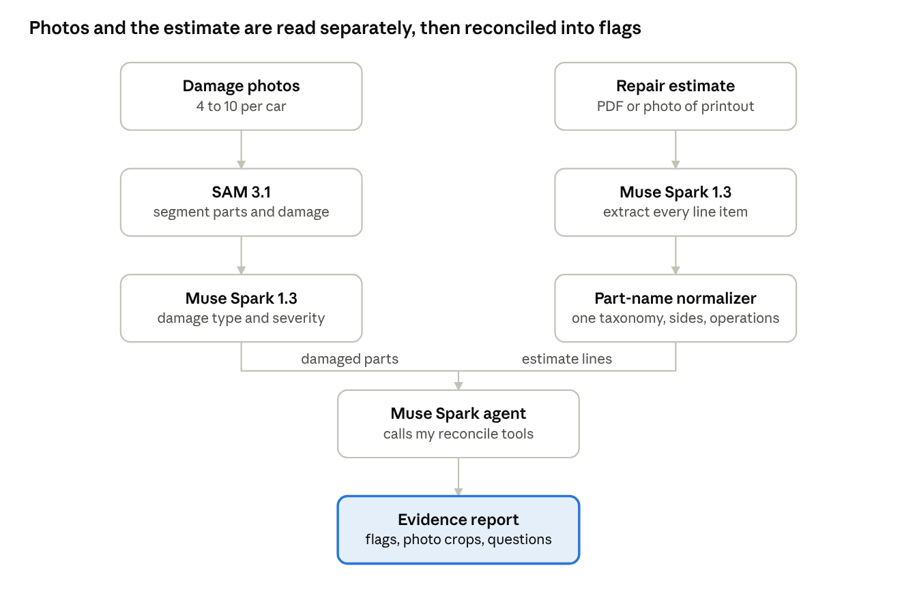
ClaimLens pipeline · 8 stages
Photos and the estimate each take their own path through the Meta Model API; in the reconcile step, Muse Spark acts as an agent that calls tools.
Stack. Python with the OpenAI-compatible SDK pointed at the Meta Model API; FastAPI; DuckDB storing photos, masks, assessments, estimate lines and every tool call; Pydantic models that generate the API's JSON schemas; a part-name taxonomy table; Streamlit for the report.
The hard part. Estimates and photos describe the same car in different vocabularies, so reconciling them is entity resolution: normalize part names and sides, match on part plus location, score each match. The agent proposes and code decides: a flag exists only if record_flag accepts it against the schema with evidence attached. Every tool call is logged in DuckDB, so the report can be audited.
Models I'm deliberately not using. Muse Voice Transcribe, because ClaimLens takes no voice input. Muse Spark Open, because it's a very large model meant for hosted deployment; Muse Glimmer is the open model that fits a private, on-device mode. Muse Wonder through the API, because Muse Spark handles this agent loop at a fraction of the cost.

5. Build plan and how I'll prove it works
A rough end-to-end version runs by day 5; the rest is accuracy and the evaluation.
- Meta Model API key and SDK client; first structured-output call; DuckDB schema; Pydantic contracts for damage and estimate lines; part-name taxonomy.
- Muse Spark lists visible parts per photo; SAM 3.1 segments those parts and the damage; damaged-part crops for one car.
- Muse Spark damage assessment (image input) and estimate extraction (PDF input). First end-to-end report.
- Agent loop on the Responses API: tool definitions, parallel tool calls, record_flag validation, tool-call logging.
- Build the test set with real photos and Muse Image variants (below); seed the estimates; first evaluation.
- Fix the worst failure mode; tune reasoning effort per step and turn on prompt caching.
- Report UI with evidence crops; final evaluation with cost per car.
- README with results.
Evaluation with seeded errors. The test set has two sources. Real photos: [20] damaged-car photo sets from a public car-damage dataset. Synthetic photos: Muse Image edits clean car photos to add a dent, scratch or crack at a spot I choose (about $0.01 per image), so we know exactly where the damage is. For each car write a correct estimate, then copy it and inject known errors: a phantom line, a missing line, replace swapped for repair, a duplicate, inflated hours. Because we know what's wrong, we can measure what ClaimLens catches. Real and synthetic results are reported separately, so the synthetic set can't flatter the numbers.
Measure | Target
Injected errors caught (recall) | 80% or more
Flags that are real problems (precision) | 75% or more
Estimate lines extracted correctly | 90% or more
Damaged parts found on synthetic photos | 85% or more
Model outputs that pass schema validation | 100%
Time from upload to report | Under 2 minutes
Meta Model API cost per car (SAM 3.1 + Muse Spark) | Under $0.50
These are targets; the README will report the real numbers either way.

6. Risks and fallbacks
Risk | Fallback
SAM 3.1 misses subtle damage like light scratches | Segment parts first, then let Muse Spark judge damage on each part crop; mark low-confidence parts "not visible in photos" rather than "undamaged"
Estimate formats vary a lot | Support one common printed layout first; schema validation rejects lines that don't parse instead of guessing
The agent loops or calls tools it doesn't need | Cap tool-call rounds per car; tools are deterministic and idempotent, so a retry is safe
Muse Image damage looks unrealistic | Real-photo results stay the headline numbers; synthetic results are reported separately
API rate limits or latency during the demo | Cache every model response in DuckDB by input hash; the demo replays cached runs if the API is slow
Hidden damage (behind a bumper) can't be photographed | Treat lines for hidden parts as "needs explanation", not errors
Scope creep | Cut order if behind: Labor-hour ranges, then repair-vs-replace. Missing and phantom lines ship regardless

